**DEPARTMENT OF CHEMISTRY**

**SRM INSTITUTE OF SCIENCE AND TECHNOLOGY**

**B.TECH (AY 2022-2023)**

**MODULE V**

Subject/Code: Chemistry/ 21CYB101J MCQs

1. After the proportionality limit in the stress strain curve, we observe ……………….
2. Ultimate point
3. Lower yield point
4. Upper yield point
5. **Elastic limit**
6. In fiber reinforced composites longitudinal strength is mainly influenced by ………….
7. **Fiber strength**
8. Fiber orientation
9. Fiber volume fraction
10. Fiber length
11. For use in automobile parts Al-alloys are reinforced to increase their ……………..
12. **Wear resistance**
13. Strength
14. Elastic modulus
15. Density
16. In fiber reinforced composites which constituent will fail last ………….
17. **Matrix**
18. Filler
19. Both fail at same time
20. Cannot define
21. In storage battery plates the matrix commonly used is ……………..
22. Aluminium
23. **Lead**
24. Silver
25. Copper
26. Fibers having thin crystals is called as ……………..
27. Wires
28. Fibers
29. **Whiskers**
30. Matrix
31. Tensile strain deformation which occurs after the ultimate amount of stress is ………..
32. Lower yield point
33. **Necking**
34. Elastic limit
35. Yield plateau
36. A wire with a radius of 5mm is hung freely from the ceiling. A load of 5N is applied to its free end. Find the elongation in the wire if its volume is 7.85*10-5m3 & young’s modulus is 1011N/m2.

a) 6.21*10-7m

b) 7.00*10-7m

c) 6.36*10-7m

d) 8.00*10-9m

# Answer: c

Explanation: The initial length of wire is Vol / πr2 = 7.85*10-5/ π*0.0052 = 1m. Stress = Y*strain. F/A = Y*Δl / l.

Δl = F/A * l/Y = (5/πr2)*(1/1011)

= 6.37*10-7m

1. A wire has a young’s modulus of 105N/m2, length 1m & radius 3mm. Assuming a uniform cross- sectional area, find the radius of wire after it is under a force of 1N from both ends.

a) 2.58m b) 2.30m c) 3.54m d) 2.24m

# Answer: a)

Explanation:

Force = 1N.

Initial area = πr2 = 2.82*10-5m2. Stress = Y*Strain

Δl = F/A * l/Y = (1/2.82*10-5) * (1/105) = 0.35m

As volume will remain same (we can also say that product of l & r2 will be constant as other terms in expression of volume are constants).

1*32 = 1.35*R2

⇒R = 2.58m.

1. In the given system, masses are released from rest. The young’s modulus of wire is 1011N/m2, length = 1m & radius = 2mm. Find elongation in wire when masses are moving. Assume pulley to be frictionless.

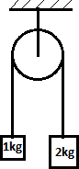

a) 1.05*10-5m

b) 2*10-5m

c) 3*10-5m

d) 0.5*10-5m

# Answer: a

Explanation: Let the tension in rope be ‘T’ & acceleration of masses be ‘a’. 2g-T=2a & T-1g=1a.

On solving these equations we get, T = 4g/3 = 1.33g. For rope, Stress = Y*Strain.

∴ T/A = Y*Δl / l (where A is area of rope & l is initial length)

∴ Δl = (1.33g/πr2)*(1/1011) = 1.05*10-5 m.

1. Which of the following quantities have the same S.I. unit as that of modulus of elasticity?
   1. Energy per unit volume b. Force per unit length c. Energy d. Change in length

# Answer: a

Explanation: Modulus of elasticity is the ratio of stress to strain. Its unit is, therefore, N/m2. Energy per unit volume has the unit Nm/m3 = N/m2. Force per unit length has the unit N/m. So, the correct answer is energy per unit volume.

1. Which of the following represents volumetric strain?
   1. -ΔV/V b. ΔV/V c. Pressure/Volume d. -P / (ΔV/V)

# Answer: b

Explanation: The volumetric strain is defined as ratio of change in volume to original volume.

It can be either positive or negative. The option -P / (ΔV/V) is the bulk modulus which is basically the ratio of volumetric stress to volumetric strain.

1. Select the correct option. B is bulk modulus.
   1. Bgas > Bliquid > Bsolid b. Bliquid > Bgas> Bsolid c. Bsolid > Bliquid > Bgas d. Bliquid > Bgas > Bsolid

# Answer: c

Explanation: Bulk modulus is the inverse of compressibility. Solids are the least compressible, followed by liquids and then gases being the most compressible. Thus solids have the maximum B, and liquids the least.

1. Which of the following stresses causes change in density, as long as force acts on the body?
   1. Shear stress b. Compressive Stress c. Tensile stress d. Volumetric stress

# Answer: d

Explanation: Volumetric stress is due to forces applied on the surface of a body from all directions such force is along normal at each point. This causes a change in volume while mass, obviously, remains the same. So, there is a slight change in density. Note that it is negligible but this change of density doesn’t occur in any other type of stresses, as the change in longitudinal length is compensated by change in lateral length in case of longitudinal stresses.

1. Which of the following options is correct?

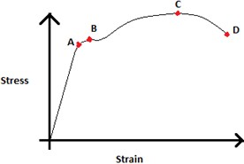

* 1. A – yield point, B – elastic limit, C – fracture point, D – Ultimate tensile strength
  2. A – yield point, B – proportional limit, C – Ultimate tensile strength, D – fracture point
  3. A – proportional limit, B – yield point, C – Ultimate tensile strength, D – fracture point
  4. A – yield point, B – proportional limit, C – fracture point, D – Ultimate tensile strength

**Answer: c**

Explanation: The point A refers to the point till which Hooke’s law can be followed, i.e: stress/ strain. It is also called the proportional limit. The point B refers to the point upto which if stress is applied the metal, on removal of stress, will regain its natural length. It is called yield point or elastic limit. The point C refers to the maximum tensile strength. And point D refers to the point where the material breaks or fractures.

1. The stress corresponding to fracture point is called
   1. ultimate stress b. breaking stress c. yield stress d. plastic stress

# Answer: b

Explanation: Breaking stress refers to the stress at which the material fractures. Ultimate stress is the maximum stress a material can handle before breaking. The material doesn’t fracture at this stress. Yield stress refers to the stress after which plastic deformation begins.

1. Which of the following statements is correct for ductile materials.
   1. Large deformation takes place between elastic limit and fracture point
   2. Have no proportional limit
   3. Break immediately after proportional limit
   4. Cannot be drawn into wires

# Answer: a

Explanation: Ductile materials are those which can be drawn into wires as they deform by a significant amount between elastic limit and fracture point. The stress-strain curve of a ductile material looks like:

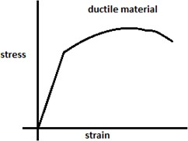

1. Which of the following statements is correct for brittle materials.
   1. It breaks soon after elastic limit is crossed
   2. It shows significant plastic deformation before breaking
   3. It is used to make wires
   4. Stress is never proportional to strain

# Answer: a

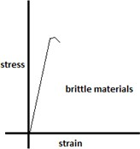Explanation: Brittle materials break soon after elastic limit. They show no significant plastic deformation and hence can’t be used for making wires. Their stress-strain curve looks like:

1. What does the area under the stress-strain curve represent?
   1. Toughness b. Total deformation c. Modulus of elasticity d. Average force applied

# Answer: a

Explanation: Area under the stress-strain curves represents toughness. Total deformation is given by the net strain multiplied by original length. Modulus of elasticity is the ratio of stress to strain under elastic limit.

1. The continuous phase of a composite material is known as its _
   1. dispersed phase b. surrounding phase c. matrix phase d. fiber phase

# Answer: c

Explanation: Composite materials contain mostly two phases: matrix and dispersed phase. Matrix phase is a continuous phase which tends to bind the fibers together. It also protects them from damage and is used to transmit the load.

1. Which of the following structures represents that of a fiber composite?

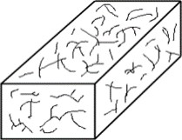a) 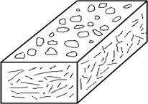b)  c) d) 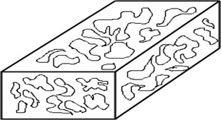

# Answer: c

Explanation: Fiber-reinforced composites are those which contain fiber form in its dispersed phase. When these fibers are parallel to each other, they exhibit high strength.

1. How is the critical length or a composite material defined?
   1. b) c) d)

# Answer: b

Explanation: The critical length of a material is determined using the diameter of the fiber, ultimate strength, and its yield strength. The critical length of the fiber is required for strengthening of the composite materials.

1. The classification of fibers having thin crystals is known as
   1. Whisker b. Fiber c. Wires d. Matrix

# Answer: a

Explanation: Whiskers are thin single crystals having an extremely large length-to-diameter ratio. Due to their small size, they have high crystalline perfection. Fibers are polycrystalline materials of small diameters, whereas wires have large diameters.

1. Which of the following materials are common for whiskers?
   1. Graphite, silicon carbide b. Glass, boron c. Steel, tungsten d. Polymers, ceramics

# Answer: a

1. Kevlar is a type of material.
   1. Glass b. Thermoplastic c. Whisker d. Polymer

# Answer: d

1. Which of the following is not a characteristic trait of composite materials?
   1. High strength, toughness, modulus b. Lightweight c. Easy to assemble d. Sensitive to temperature change

# Answer: d

1. Fiberglass materials have a usable temperature up to _
   1. 50oC b. 100oC c. 200oC d. 500oC

# Answer: c

1. What is the purpose of fiberglass that is made as a thread?
   1. Insulating material b. Conductive material c. Heat resistant d. Cloth

# Answer: d

1. 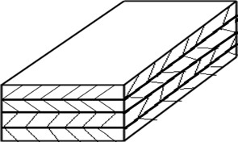The below figure depicts the structure of composite materials.
2. Discontinuous
3. Aligned
4. Laminate
5. Dispersion-strengthened

# Answer: c

1. 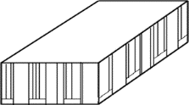The below figure is an example of type of structural composites.
   1. Laminar b. Sandwich panel c. Discontinuous d. Randomly oriented

# Answer: b

1. How is carbon fibre manufactured?
   1. Heating b. Thermal degradation of PAN c. Cooling of PAN d. Thermal degradation of polyethylene

# Answer: b

1. What are the sequence of steps involved in the manufacture of carbon fibre?
   1. Cooling-Carbonization-Graphitization b. Graphitization-Carbonization-Cooling c. Heating-Carbonization-Graphitization d. Graphitization-Carbonization-Heating

# Answer: c

1. Which of the following is also known as X-ray photoelectron spectroscopy?
   1. Auger electron spectroscopy b. Electron impact spectroscopy c. **Electron spectroscopy for chemical analysis** d. Secondary ion mass spectroscopy
2. Which of the following methods use soft X-rays to eject electrons from inner shell orbitals?
   1. Auger electron spectroscopy b. Electron impact spectroscopy c. X-ray crystallography d. **X-ray photoelectron spectroscopy**
3. The energy required to remove an electron from the highest occupied atomic orbital is known as -------.
   1. **Ionization energy** b) Kinetic energy c) Binding energy d) Vibrational energy
4. X-ray diffractometers are not used to identify the physical properties of which of the following?
   1. Metals **b) Liquids** c) Polymeric materials d) Solids
5. Minimum interplanar spacing required for Bragg’s diffraction is
   1. λ/4 **b) λ/2** c) 4λ d) 2λ
6. The Bragg’s equation for diffraction of X-rays is
   1. nλ = 2d2sinθ **b) nλ = 2dsinθ** c) nλ = 2dsin2θ d) nλ = d2sinθ
7. The source for XPS is -----
   1. Mercury - arc
   2. Nernst glower
   3. Globar source

# AlKα

1. In XPS, the primary and secondary beams consist of

# X-ray photon, electron b. electrons, X-ray photon c. electrons, electrons d. UV-photons, electrons

1. Repeatable entity of a crystal structure is known as

a. crystal b. Lattice c. **unit cell** d. miller indices

1. The scattering of waves in Bragg’s law experiment is due to _
   1. Einstein’s scattering b. Rayleigh scattering c. Newton scattering d. Inelastic scattering

# Answer: b

1. If the angle of incidence is 30°, then the wavelength for first-order spectrum is equal to

a) d. b) 2d c) d/2 d) d/3

# Answer: a

Explanation: We know, nλ = 2dsinθ. As, θ = 30° and n = 1, we get λ = d.

1. If X-ray of wavelength 100 Å is incident on an atom at an angle of 90°, then what should be the value of d for first-order spectrum?
   1. 30 Å b. 40 Å c. 50 Å d. 60 Å

# Answer: c

Explanation: We know, nλ = 2dsinθ. Here, λ = 10-8 m, n = 1, sinθ = 1.

Therefore, 10-8 = 2 * d * 1 d = 50 Å.

1. What should be the value of X?

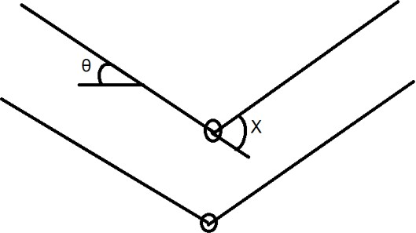

* 1. θ b. θ/2 c. 2 θ d. θ/3

# Answer: c

Explanation: As we can see in the following figure, the angle X is between the incident light and the diffracted light. This angle should be 2θ, as the angle made by both with horizontal plane would be θ.

1. For destructive interference to take place, the path difference between the two waves should be
   1. nλ b. 2nλ c.(n + 1/2) λ d. (2n + 1)λ

# Answer: a

1. In Bragg’s equation [nλ = 2.d.sinθ], θ is the angle between:
   1. specimen surface and incident rays

b. normal to specimen surface and incident rays

c. parallel lattice surfaces distance apart and incident rays

d. normal to parallel lattice surfaces d distance apart and incident rays

# Answer: c

# PART B ( 2/4/6/10/15 Marks)

1. Draw and explain all the regions in the stress-strain plot.
2. With proper examples explain ceramic matrix composite and metal matrix composites.
3. What are composites? Explain in detail particle reinforced composites, fiber reinforced composites and metal matrix composites
4. Discuss the principle, instrumentation and applications of XPS.
5. Explain Bragg’s law with a neat diagram.
6. Explain the principle of XPS?
7. Define Miller indices with examples.
8. For the intercepts x, y, and, z with values of 3, 1, and 2 respectively, find the Miller indices.
9. Compute the Miller Indices for a plane intersecting at x= ¼, y=1, and z=1/2.
10. Give the expression for Bragg’s law and explain the terms involved in it.
11. What is inter-plane spacing’s in lattices? Give the expression taking an example.
12. Determine the Miller indices (hkl) of the shaded planes below. Show your work on each step of Miller indices to determine the plane.
13.  b.  c. 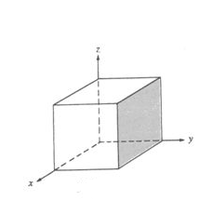
14. Define composite material.
15. What is the need for composite material?
16. Mention important characteristic of composite material
17. Give examples for fiber material
18. Mention important matrix materials.
19. Classify composite material.
20. What is the role of matrix is a composite material?
21. What is the role reinforcement in composite materials?
22. What are the advantages of composite materials?
23. Give examples use of composite materials.
24. List types of fibres used in FRP.
25. What are various types of Matrices used in FRP?
26. What is meant by stress?
27. Define the stress-strain curve.
28. What is the formula to calculate the strain?
29. Define elasticity.
30. What is meant by tensile stress?
31. Define from the following pictures given: [ Ans: a. tensile stress b. shear stress]
32. 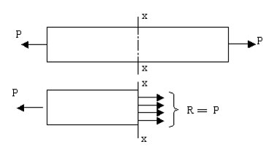b. 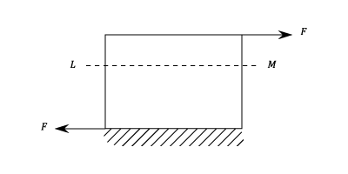
33. Define a. compressive stress b. Hooke’s law c. lateral strain d. Poisson’s ratio
34. Explain the points given in stress-strain curve below:

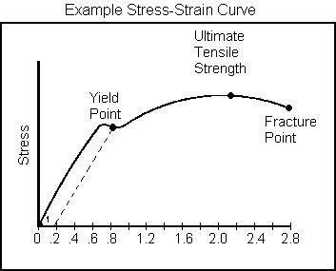

1. Differentiate between ultimate stress and breaking stress.
2. Stress Versus strain curve is given below for two materials A and B. Compare and explain which will be more ductile?

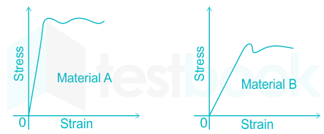

**Ans:** Material B is more ductile. **Ductility is the property of the material that enables it to be drawn out or elongated to an appreciable extent before rupture occurs. The percentage elongation or percentage reduction in area before rupture of a test specimen is the measure of ductility. Normally if percentage elongation exceeds 15% the material is ductile and if it is less than 5% the material is brittle. Lead, copper, aluminum, mild steel are typical ductile materials. And from this we can conclude that greater the Young’s modulus means that the material is less ductile. Hence from making thin wire and instruments like that we need more ductile material, which means that for such material Young’s modulus must be low. Where, F = force applied; A = area of cross section; ∆L = change in length; L = original length . From the above example we can see that steeper the slope larger would be the Young’s modulus, thus it will be difficult to draw wires from such material and it will be less ductile. Thus, material A is stronger compared to B, whereas B is more ductile compared to A .**

1. The stress- strain curve of three materials A, B and C are given. Which of the following material will have maximum Modulus of Elasticity?

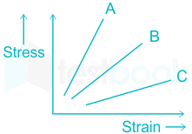

**Ans:** A

